

Ministry of Education and Research of the Republic of Moldova

Technical University of Moldova

Department of Software and Automation Engineering

**REPORT**

Individual Work No. 4

**Discipline**: Signal Processing

Elaborated: Berco Andrei, FAF - 221

Checked: Railean Serghei

Chișinău 2025

**Purpose of the work**

The purpose of this work is to explore and understand the fundamental methods of linear image processing using MATLAB, including arithmetic operations on images, histogram equalization, spatial and frequency domain filtering, and edge detection. The lab aims to provide practical experience in modifying image brightness, contrast, and sharpness, analyzing histograms, and applying various filters to enhance or extract image features.

**Theoretical Notes**

1. Arithmetic Operations on Images

Image pixels (gray levels between 0 and 255) can be modified by applying simple mathematical functions:

* Addition/Subtraction of a constant:
  + Brightens or darkens the image.
  + E.g., adding 128: all pixel values ≥ 127 become 255 (white); subtracting 128: values ≤ 128 become 0 (black).
* Multiplication/Division by a constant:
  + Enhances or reduces image brightness proportionally.

Important: Pixel values must remain in the 0–255 range. This is achieved by rounding results and clipping:

* If result > 255 → set to 255
* If result < 0 → set to 0

2. Histogram Equalization

* A histogram shows the distribution of gray levels in an image.
* Low contrast image → gray levels are concentrated in a small part of the histogram.
* Histogram equalization stretches out the pixel distribution to improve image contrast.
* MATLAB commands:

imshow(p), figure, imhist(p), axis tight

3. Image Filtering – Spatial Filtering

* Filtering modifies a pixel based on its neighborhood.
* In spatial filtering, a mask (usually of odd dimensions like 3×3 or 5×5) slides over the image.
* Each pixel in the output is calculated as:

new_pixel = sum(mask .* neighborhood)

* If the operation is a linear combination → it's called linear filtering.

Steps:

1. Place the mask on the current pixel.
2. Multiply each mask value by the corresponding pixel value under it.
3. Sum all the products to get the new pixel value.

**Practical Tasks**

1. **GAMMA CURVE MANIPULATION**
   1. Display an image of your choice using imshow, and first save this image to:  
      C:\MATLAB\toolbox\images\imdemos\????.tif.Read the image and select a 256x256 region

#Ex 1.1

import imageio.v3 as iio

import matplotlib.pyplot as plt

import numpy as np

# Step 1: Read the image

# Replace 'image.tif' with the name of an image file (e.g., 'cameraman.tif')

# For this example, I'll assume a sample image. You can download 'cameraman.tif' or use any .tif image.

image_path = 'image.tiff'

c = iio.imread(image_path)

# Step 2: Select a 256x256 region from the image

# Ensure the image is large enough; we'll take the top-left 256x256 region

# cc = c[2:257, 2:257] if c.ndim == 2 else c[1:257, 1:257, :]

height, width = c.shape[:2]

start_y = (height - 256) // 2

start_x = (width - 256) // 2

cc = c[start_y:start_y + 256, start_x:start_x + 256] if c.ndim == 2 else c[start_y:start_y + 256, start_x:start_x + 256, :]

# Step 3: Display the original and cropped images

plt.figure(figsize=(10, 5))

# Original image

plt.subplot(1, 2, 1)

plt.imshow(c, cmap='gray' if c.ndim == 2 else None)

plt.title('Original Image')

plt.axis('off')

# Cropped image

plt.subplot(1, 2, 2)

plt.imshow(cc, cmap='gray' if c.ndim == 2 else None)

plt.title('Cropped 256x256 Region')

plt.axis('off')

plt.tight_layout()

plt.show()

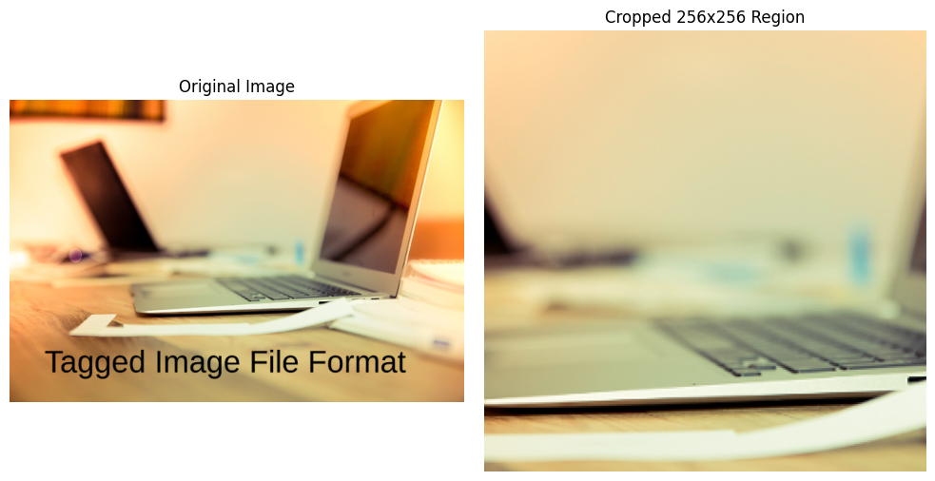

Figure 1: Result for task 1.1

* 1. Add 128 to each pixel value in the imageAdd 128 to each pixel value in the image

#Ex 1.2

import imageio.v3 as iio

import matplotlib.pyplot as plt

import numpy as np

# Step 1: Read the image

# Replace 'cameraman.tif' with your image path

image_path = 'image.tiff'  # Update with your image path, e.g., 'C:/MATLAB/toolbox/images/imdemos/cameraman.tif'

c = iio.imread(image_path)

# Step 2: Crop a 256x256 region from the center

height, width = c.shape[:2]

start_y = (height - 256) // 2

start_x = (width - 256) // 2

cc = c[start_y:start_y + 256, start_x:start_x + 256] if c.ndim == 2 else c[start_y:start_y + 256, start_x:start_x + 256, :]

# Step 3: Add 128 to each pixel value

# Ensure pixel values stay within valid range (0-255 for uint8)

c1 = np.clip(cc.astype(np.int16) + 128, 0, 255).astype(np.uint8)

# Step 4: Display the original cropped and modified images

plt.figure(figsize=(10, 5))

# Original cropped image

plt.subplot(1, 2, 1)

plt.imshow(cc, cmap='gray' if cc.ndim == 2 else None)

plt.title('Original Cropped Image (Center)')

plt.axis('off')

# Modified image (after adding 128)

plt.subplot(1, 2, 2)

plt.imshow(c1, cmap='gray' if c1.ndim == 2 else None)

plt.title('Image with 128 Added to Pixels')

plt.axis('off')

plt.tight_layout()

plt.show()

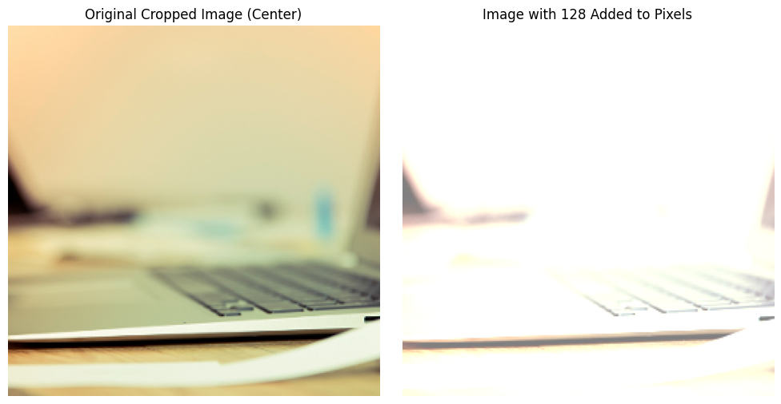

Figure 2: Result for task 1.2

* 1. Subtract 128 from each pixel value in the image

#Ex 1.3

import imageio.v3 as iio

import matplotlib.pyplot as plt

import numpy as np

# Step 1: Read the image

# Using the specified image name 'image.tiff'

image_path = 'image.tiff'  # Update with your full path, e.g., 'C:/MATLAB/toolbox/images/imdemos/image.tiff'

c = iio.imread(image_path)

# Step 2: Crop a 256x256 region from the center

height, width = c.shape[:2]

start_y = (height - 256) // 2

start_x = (width - 256) // 2

cc = c[start_y:start_y + 256, start_x:start_x + 256] if c.ndim == 2 else c[start_y:start_y + 256, start_x:start_x + 256, :]

# Step 3: Subtract 128 from each pixel value

# Ensure pixel values stay within valid range (0-255 for uint8)

c2 = np.clip(cc.astype(np.int16) - 128, 0, 255).astype(np.uint8)

# Step 4: Display the original cropped and modified images

plt.figure(figsize=(10, 5))

# Original cropped image

plt.subplot(1, 2, 1)

plt.imshow(cc, cmap='gray' if cc.ndim == 2 else None)

plt.title('Original Cropped Image (Center)')

plt.axis('off')

# Modified image (after subtracting 128)

plt.subplot(1, 2, 2)

plt.imshow(c2, cmap='gray' if c2.ndim == 2 else None)

plt.title('Image with 128 Subtracted from Pixels')

plt.axis('off')

plt.tight_layout()

plt.show()

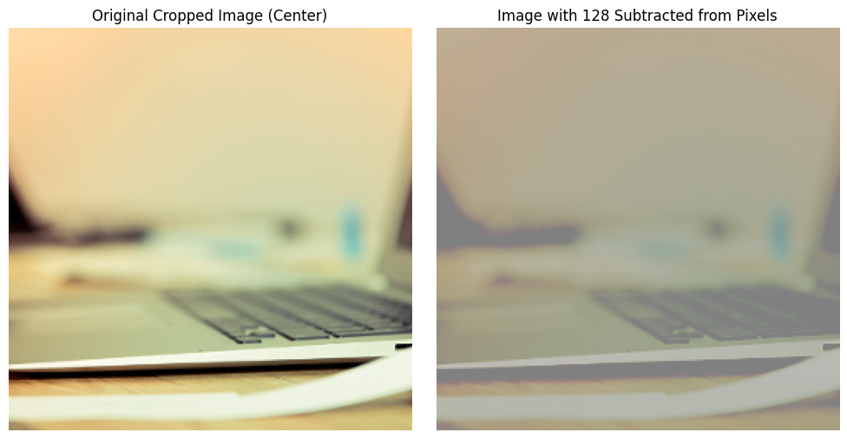

Figure 3: Result for task 1.3

* 1. Divide each pixel value by 2

#Ex 1.4

import imageio.v3 as iio

import matplotlib.pyplot as plt

import numpy as np

# Step 1: Read the image

# Using the specified image name 'image.tiff'

image_path = 'image.tiff'  # Update with your full path, e.g., 'C:/MATLAB/toolbox/images/imdemos/image.tiff'

c = iio.imread(image_path)

# Step 2: Crop a 256x256 region from the center

height, width = c.shape[:2]

start_y = (height - 256) // 2

start_x = (width - 256) // 2

cc = c[start_y:start_y + 256, start_x:start_x + 256] if c.ndim == 2 else c[start_y:start_y + 256, start_x:start_x + 256, :]

# Step 3: Divide each pixel value by 2

# Ensure pixel values stay within valid range (0-255 for uint8)

c3 = (cc.astype(np.float32) / 2).astype(np.uint8)

# Step 4: Display the original cropped and modified images

plt.figure(figsize=(10, 5))

# Original cropped image

plt.subplot(1, 2, 1)

plt.imshow(cc, cmap='gray' if cc.ndim == 2 else None)

plt.title('Original Cropped Image (Center)')

plt.axis('off')

# Modified image (after dividing by 2)

plt.subplot(1, 2, 2)

plt.imshow(c3, cmap='gray' if c3.ndim == 2 else None)

plt.title('Image with Pixels Divided by 2')

plt.axis('off')

plt.tight_layout()

plt.show()

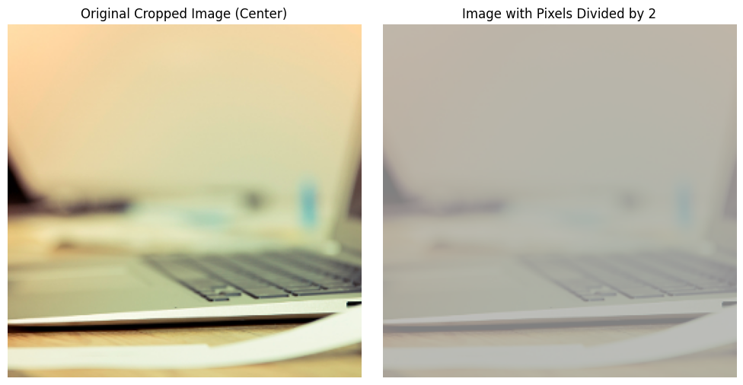

Figure 4: Result for task 1.4

* 1. Multiply each pixel value by 2

#Ex 1.5

import imageio.v3 as iio

import matplotlib.pyplot as plt

import numpy as np

# Step 1: Read the image

# Using the specified image name 'image.tiff'

image_path = 'image.tiff'  # Update with your full path, e.g., 'C:/MATLAB/toolbox/images/imdemos/image.tiff'

c = iio.imread(image_path)

# Step 2: Crop a 256x256 region from the center

height, width = c.shape[:2]

start_y = (height - 256) // 2

start_x = (width - 256) // 2

cc = c[start_y:start_y + 256, start_x:start_x + 256] if c.ndim == 2 else c[start_y:start_y + 256, start_x:start_x + 256, :]

# Step 3: Multiply each pixel value by 2

# Ensure pixel values stay within valid range (0-255 for uint8)

c4 = np.clip(cc.astype(np.int16) * 2, 0, 255).astype(np.uint8)

# Step 4: Display the original cropped and modified images

plt.figure(figsize=(10, 5))

# Original cropped image

plt.subplot(1, 2, 1)

plt.imshow(cc, cmap='gray' if cc.ndim == 2 else None)

plt.title('Original Cropped Image (Center)')

plt.axis('off')

# Modified image (after multiplying by 2)

plt.subplot(1, 2, 2)

plt.imshow(c4, cmap='gray' if c4.ndim == 2 else None)

plt.title('Image with Pixels Multiplied by 2')

plt.axis('off')

plt.tight_layout()

plt.show()

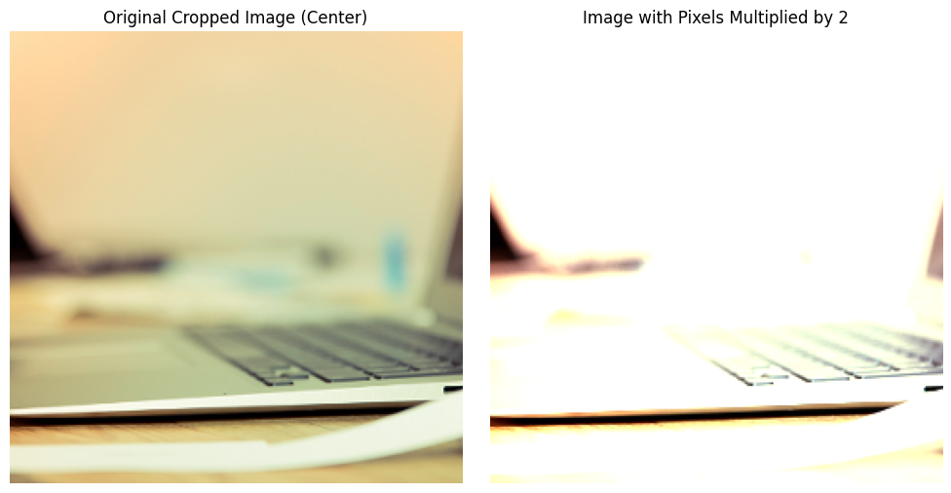  
Figure 5: Result for task 1.5

* 1. Multiply each pixel by 0.5 and then add 128

#Ex 1.6

import imageio.v3 as iio

import matplotlib.pyplot as plt

import numpy as np

# Step 1: Read the image

# Using the specified image name 'image.tiff'

image_path = 'image.tiff'  # Update with your full path, e.g., 'C:/MATLAB/toolbox/images/imdemos/image.tiff'

c = iio.imread(image_path)

# Step 2: Crop a 256x256 region from the center

height, width = c.shape[:2]

start_y = (height - 256) // 2

start_x = (width - 256) // 2

cc = c[start_y:start_y + 256, start_x:start_x + 256] if c.ndim == 2 else c[start_y:start_y + 256, start_x:start_x + 256, :]

# Step 3: Multiply each pixel value by 0.5 and add 128

# Ensure pixel values stay within valid range (0-255 for uint8)

c5 = np.clip((cc.astype(np.float32) * 0.5 + 128), 0, 255).astype(np.uint8)

# Step 4: Display the original cropped and modified images

plt.figure(figsize=(10, 5))

# Original cropped image

plt.subplot(1, 2, 1)

plt.imshow(cc, cmap='gray' if cc.ndim == 2 else None)

plt.title('Original Cropped Image (Center)')

plt.axis('off')

# Modified image (after multiplying by 0.5 and adding 128)

plt.subplot(1, 2, 2)

plt.imshow(c5, cmap='gray' if c5.ndim == 2 else None)

plt.title('Image with Pixels *0.5 + 128')

plt.axis('off')

plt.tight_layout()

plt.show()

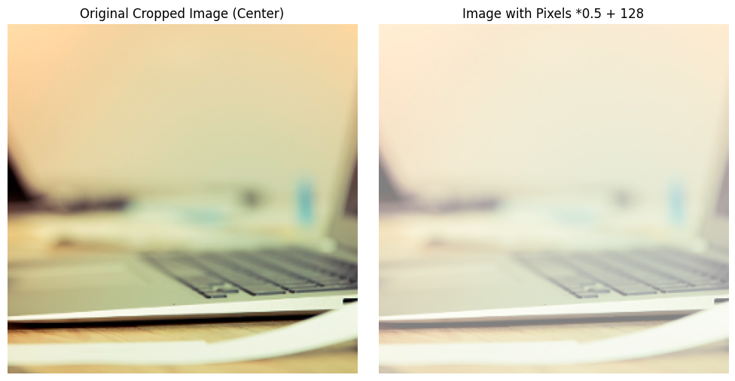

Figure 6: Result for task 1.6

1. **HISTOGRAM EQUALIZATION**
   1. Display the image and its histogram:

#Ex 2.1

import imageio.v3 as iio

import matplotlib.pyplot as plt

import numpy as np

# Step 1: Read the image

# Using the specified image name 'image.tiff'

image_path = 'image.tiff'  # Update with your full path, e.g., 'C:/MATLAB/toolbox/images/imdemos/image.tiff'

c = iio.imread(image_path)

# Step 2: Crop a 256x256 region from the center

height, width = c.shape[:2]

start_y = (height - 256) // 2

start_x = (width - 256) // 2

cc = c[start_y:start_y + 256, start_x:start_x + 256] if c.ndim == 2 else c[start_y:start_y + 256, start_x:start_x + 256, :]

# Step 3: Compute histograms for RGB channels (if color image)

if c.ndim == 3:  # RGB image

    R, bins = np.histogram(cc[:, :, 0].ravel(), bins=256, range=(0, 256))

    G, _ = np.histogram(cc[:, :, 1].ravel(), bins=256, range=(0, 256))

    B, _ = np.histogram(cc[:, :, 2].ravel(), bins=256, range=(0, 256))

else:  # Grayscale image (fallback)

    R, bins = np.histogram(cc.ravel(), bins=256, range=(0, 256))

    G, B = None, None  # No green or blue channels

# Step 4: Display the image and histogram

plt.figure(figsize=(12, 5))

# Display the cropped image

plt.subplot(1, 2, 1)

plt.imshow(cc, cmap='gray' if c.ndim == 2 else None)

plt.title('Cropped Image (Center 256x256)')

plt.axis('off')

# Display the histogram

plt.subplot(1, 2, 2)

if c.ndim == 3:  # RGB histogram

    plt.plot(R, 'r', label='Red channel')

    plt.plot(G, 'g', label='Green channel')

    plt.plot(B, 'b', label='Blue channel')

    plt.legend()

else:  # Grayscale histogram

    plt.plot(R, 'k', label='Grayscale channel')

    plt.legend()

plt.title('Histogram of Pixel Intensities')

plt.xlabel('Pixel Value')

plt.ylabel('Frequency')

plt.grid(True)

plt.tight_layout()

plt.show()

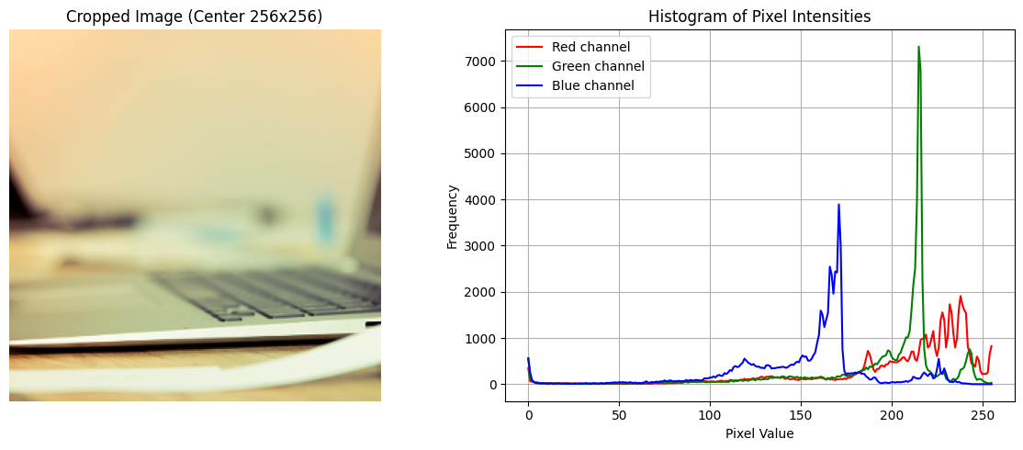

Figure 7: Result for task 2.1

* 1. Perform histogram equalization

#Ex. 2.2

import imageio.v3 as iio

import matplotlib.pyplot as plt

import numpy as np

from skimage import exposure

# Step 1: Read the image

image_path = 'image.tiff'  # Update with your full path, e.g., 'C:/MATLAB/toolbox/images/imdemos/image.tiff'

c = iio.imread(image_path)

# Step 2: Crop a 256x256 region from the center

height, width = c.shape[:2]

if height < 256 or width < 256:

    raise ValueError("Image must be at least 256x256 pixels")

start_y = (height - 256) // 2

start_x = (width - 256) // 2

cc = c[start_y:start_y + 256, start_x:start_x + 256] if c.ndim == 2 else c[start_y:start_y + 256, start_x:start_x + 256, :]

# Step 3: Check for RGBA and convert to RGB if needed

if c.ndim == 3 and c.shape[2] == 4:

    cc = cc[:, :, :3]  # Remove alpha channel

# Step 4: Compute dynamic input ranges for RGB or apply histogram equalization

if c.ndim == 3:  # RGB image

    cc_float = cc.astype(np.float32) / 255.0

    I2 = np.zeros_like(cc_float)

    # Compute percentiles for dynamic ranges (e.g., 5th to 95th percentile)

    ranges = []

    for i in range(3):  # Red, Green, Blue

        low, high = np.percentile(cc_float[:, :, i], [5, 95])

        ranges.append((low, high))

        I2[:, :, i] = exposure.rescale_intensity(cc_float[:, :, i], in_range=(low, high))

    I2 = (I2 * 255).astype(np.uint8)

else:  # Grayscale image

    I2 = exposure.equalize_hist(cc) * 255

    I2 = I2.astype(np.uint8)

    ranges = [np.percentile(cc.astype(np.float32) / 255.0, [5, 95])]  # For display

# Step 5: Compute histograms for original and adjusted images

if c.ndim == 3:

    R_orig, bins = np.histogram(cc[:, :, 0].ravel(), bins=256, range=(0, 256))

    G_orig, _ = np.histogram(cc[:, :, 1].ravel(), bins=256, range=(0, 256))

    B_orig, _ = np.histogram(cc[:, :, 2].ravel(), bins=256, range=(0, 256))

    R_adj, _ = np.histogram(I2[:, :, 0].ravel(), bins=256, range=(0, 256))

    G_adj, _ = np.histogram(I2[:, :, 1].ravel(), bins=256, range=(0, 256))

    B_adj, _ = np.histogram(I2[:, :, 2].ravel(), bins=256, range=(0, 256))

else:

    R_orig, bins = np.histogram(cc.ravel(), bins=256, range=(0, 256))

    R_adj, _ = np.histogram(I2.ravel(), bins=256, range=(0, 256))

    G_orig, B_orig, G_adj, B_adj = None, None, None, None

# Step 6: Display images and histograms

# Images

plt.figure(figsize=(12, 5))

plt.subplot(1, 2, 1)

plt.imshow(cc, cmap='gray' if c.ndim == 2 else None)

plt.title('Original Cropped Image')

plt.axis('off')

plt.subplot(1, 2, 2)

plt.imshow(I2, cmap='gray' if c.ndim == 2 else None)

plt.title('Adjusted Image')

plt.axis('off')

plt.tight_layout()

plt.show()

# Histograms

plt.figure(figsize=(12, 5))

plt.subplot(1, 2, 1)

if c.ndim == 3:

    plt.plot(R_orig, 'r', label='Red channel')

    plt.plot(G_orig, 'g', label='Green channel')

    plt.plot(B_orig, 'b', label='Blue channel')

    plt.legend()

else:

    plt.plot(R_orig, 'k', label='Grayscale channel')

    plt.legend()

plt.title(f'Original Histogram')

plt.xlabel('Pixel Value')

plt.ylabel('Frequency')

plt.grid(True)

plt.subplot(1, 2, 2)

if c.ndim == 3:

    plt.plot(R_adj, 'r', label='Red channel')

    plt.plot(G_adj, 'g', label='Green channel')

    plt.plot(B_adj, 'b', label='Blue channel')

    plt.legend()

else:

    plt.plot(R_adj, 'k', label='Grayscale channel')

    plt.legend()

plt.title('Adjusted Histogram')

plt.xlabel('Pixel Value')

plt.ylabel('Frequency')

plt.grid(True)

plt.tight_layout()

plt.show()

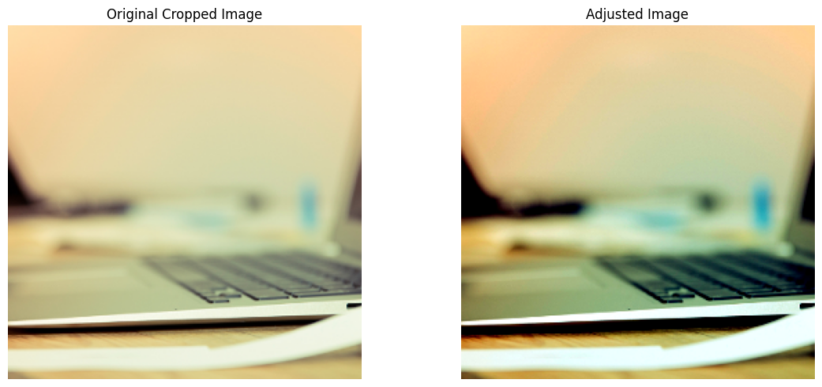

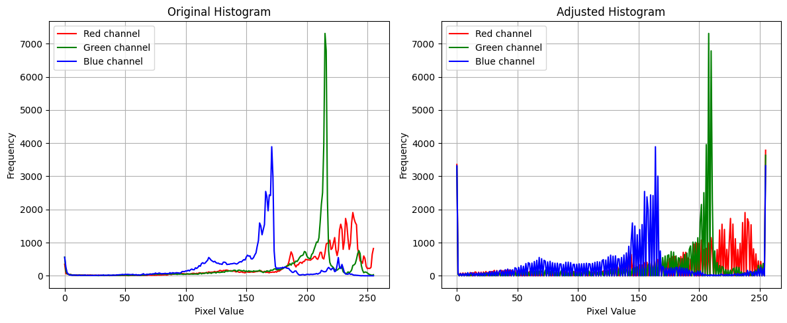

Figure 8: Result for task 2.2

1. **IMAGE FILTERING**
   1. Apply a 3x3 average filter

#Ex. 3.1

import imageio.v3 as iio

import matplotlib.pyplot as plt

import numpy as np

from scipy import ndimage

from skimage.color import rgb2gray

# Step 1: Read the image

image_path = 'image.tiff'  # Update with your full path, e.g., 'C:/MATLAB/toolbox/images/imdemos/image.tiff'

c = iio.imread(image_path)

# Step 2: Crop a 256x256 region from the center

height, width = c.shape[:2]

if height < 256 or width < 256:

    raise ValueError("Image must be at least 256x256 pixels")

start_y = (height - 256) // 2

start_x = (width - 256) // 2

cc = c[start_y:start_y + 256, start_x:start_x + 256] if c.ndim == 2 else c[start_y:start_y + 256, start_x:start_x + 256, :]

# Step 3: Handle RGB, RGBA, or grayscale image

if c.ndim == 3:  # Color image (RGB or RGBA)

    if c.shape[2] == 4:  # RGBA

        cc = cc[:, :, :3]  # Discard alpha channel to get RGB

    # Convert to grayscale (equivalent to rgb2gray)

    IG = (rgb2gray(cc) * 255).astype(np.uint8)

else:  # Grayscale image

    IG = cc

# Step 4: Create a 3x3 averaging filter (equivalent to fspecial('average'))

f1 = np.ones((3, 3)) / 9

# Step 5: Apply the filter (equivalent to filter2)

cf1 = ndimage.convolve(IG, f1, mode='constant', cval=0.0)

# Step 7: Display original grayscale and filtered images

plt.figure(figsize=(12, 5))

plt.subplot(1, 2, 1)

plt.imshow(IG, cmap='gray')

plt.title('Original Grayscale Image')

plt.axis('off')

plt.subplot(1, 2, 2)

plt.imshow(cf1, cmap='gray')

plt.title('Filtered Image (3x3 Average)')

plt.axis('off')

plt.tight_layout()

plt.show()

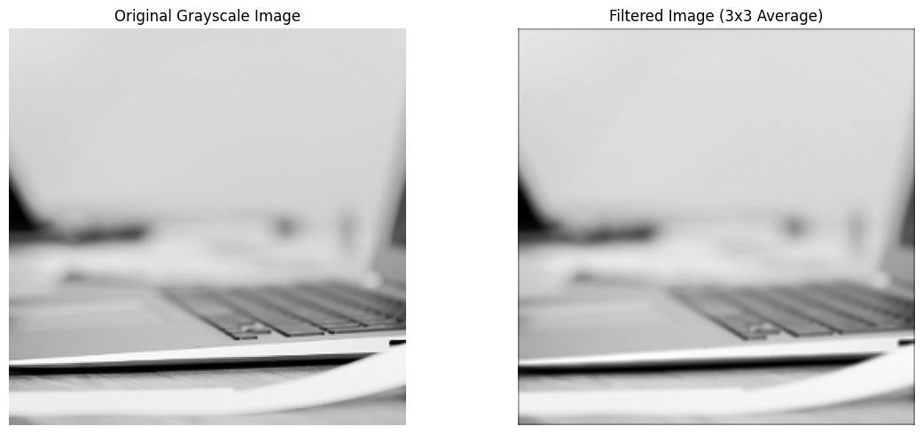

Figure 8: Result for task 3.1

* 1. Apply a 5x7 filter

#ex 3.2

import imageio.v3 as iio

import matplotlib.pyplot as plt

import numpy as np

from scipy import ndimage

from skimage.color import rgb2gray

# Step 1: Read the image

image_path = 'image.tiff'  # Update with your full path, e.g., 'C:/MATLAB/toolbox/images/imdemos/image.tiff'

c = iio.imread(image_path)

# Step 2: Crop a 256x256 region from the center

height, width = c.shape[:2]

if height < 256 or width < 256:

    raise ValueError("Image must be at least 256x256 pixels")

start_y = (height - 256) // 2

start_x = (width - 256) // 2

cc = c[start_y:start_y + 256, start_x:start_x + 256] if c.ndim == 2 else c[start_y:start_y + 256, start_x:start_x + 256, :]

# Step 3: Handle RGB, RGBA, or grayscale image

if c.ndim == 3:  # Color image (RGB or RGBA)

    if c.shape[2] == 4:  # RGBA

        cc = cc[:, :, :3]  # Discard alpha channel to get RGB

    # Convert to grayscale (equivalent to rgb2gray)

    IG = (rgb2gray(cc) * 255).astype(np.uint8)

else:  # Grayscale image

    IG = cc

# Step 4: Create a 5x7 averaging filter (equivalent to fspecial('average', [5,7]))

f1 = np.ones((5, 7)) / (5 * 7)

# Step 5: Apply the filter (equivalent to filter2)

cf1 = ndimage.convolve(IG, f1, mode='constant', cval=0.0)

# Step 7: Display original grayscale and filtered images

plt.figure(figsize=(12, 5))

plt.subplot(1, 2, 1)

plt.imshow(IG, cmap='gray')

plt.title('Original Grayscale Image')

plt.axis('off')

plt.subplot(1, 2, 2)

plt.imshow(cf1, cmap='gray')

plt.title('Filtered Image (5x7 Average)')

plt.axis('off')

plt.tight_layout()

plt.show()

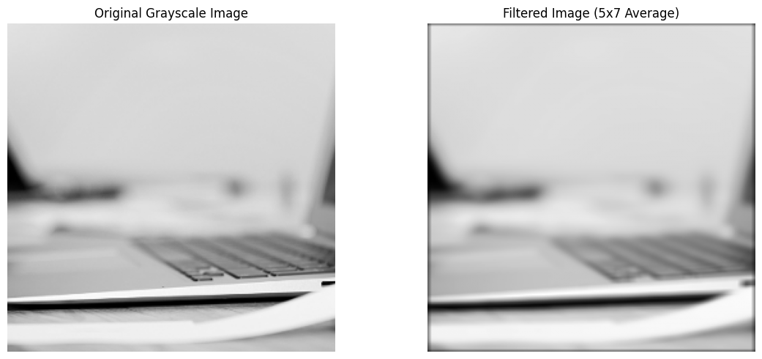

Figure 9: Result for task 3.2

* 1. Apply an 11x11 filter

#Ex 3.2

import imageio.v3 as iio

import matplotlib.pyplot as plt

import numpy as np

from scipy import ndimage

from skimage.color import rgb2gray

# Step 1: Read the image

image_path = 'image.tiff'  # Update with your full path, e.g., 'C:/MATLAB/toolbox/images/imdemos/image.tiff'

c = iio.imread(image_path)

# Step 2: Crop a 256x256 region from the center

height, width = c.shape[:2]

if height < 256 or width < 256:

    raise ValueError("Image must be at least 256x256 pixels")

start_y = (height - 256) // 2

start_x = (width - 256) // 2

cc = c[start_y:start_y + 256, start_x:start_x + 256] if c.ndim == 2 else c[start_y:start_y + 256, start_x:start_x + 256, :]

# Step 3: Handle RGB, RGBA, or grayscale image

if c.ndim == 3:  # Color image (RGB or RGBA)

    if c.shape[2] == 4:  # RGBA

        cc = cc[:, :, :3]  # Discard alpha channel to get RGB

    # Convert to grayscale (equivalent to rgb2gray)

    IG = (rgb2gray(cc) * 255).astype(np.uint8)

else:  # Grayscale image

    IG = cc

# Step 4: Create an 11x11 averaging filter (equivalent to fspecial('average', 11))

f1 = np.ones((11, 11)) / (11 * 11)

# Step 5: Apply the filter (equivalent to filter2)

cf1 = ndimage.convolve(IG, f1, mode='constant', cval=0.0)

# Step 7: Display original grayscale and filtered images

plt.figure(figsize=(12, 5))

plt.subplot(1, 2, 1)

plt.imshow(IG, cmap='gray')

plt.title('Original Grayscale Image')

plt.axis('off')

plt.subplot(1, 2, 2)

plt.imshow(cf1, cmap='gray')

plt.title('Filtered Image (11x11 Average)')

plt.axis('off')

plt.tight_layout()

plt.show()

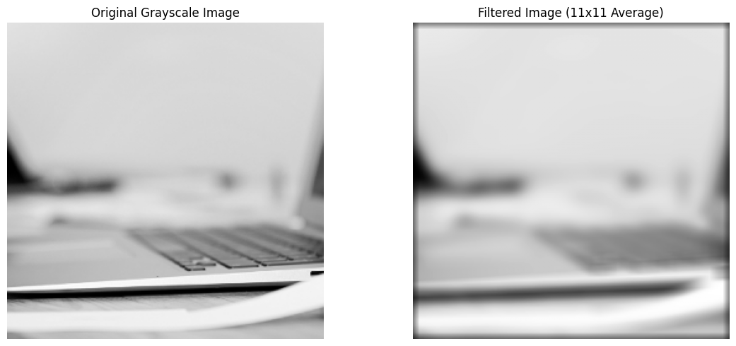

Figure 10: Result for task 3.3

* 1. Edge detection using Laplacian and Laplacian of Gaussian

#Ex 3.3

import imageio.v3 as iio

import matplotlib.pyplot as plt

import numpy as np

from scipy import ndimage

from skimage.color import rgb2gray

# Step 1: Read the image

image_path = 'image.tiff'  # Update with your full path, e.g., 'C:/MATLAB/toolbox/images/imdemos/image.tiff'

c = iio.imread(image_path)

# Step 2: Crop a 256x256 region from the center

height, width = c.shape[:2]

if height < 256 or width < 256:

    raise ValueError("Image must be at least 256x256 pixels")

start_y = (height - 256) // 2

start_x = (width - 256) // 2

cc = c[start_y:start_y + 256, start_x:start_x + 256] if c.ndim == 2 else c[start_y:start_y + 256, start_x:start_x + 256, :]

# Step 3: Handle RGB, RGBA, or grayscale image

if c.ndim == 3:  # Color image (RGB or RGBA)

    if c.shape[2] == 4:  # RGBA

        cc = cc[:, :, :3]  # Discard alpha channel to get RGB

    # Convert to grayscale (equivalent to rgb2gray)

    IG = (rgb2gray(cc) * 255).astype(np.uint8)

else:  # Grayscale image

    IG = cc

# Step 5: Create Laplacian and LoG filters (equivalent to fspecial)

# Laplacian filter (MATLAB's fspecial('laplacian', alpha=0) default)

f_laplacian = np.array([[0, 1, 0],

                        [1, -4, 1],

                        [0, 1, 0]])

# LoG filter (approximating fspecial('log', hsize=5, sigma=0.5) default)

# Using a 5x5 LoG filter with sigma=0.5

f_log = np.array([[0, 0, -1, 0, 0],

                  [0, -1, -2, -1, 0],

                  [-1, -2, 16, -2, -1],

                  [0, -1, -2, -1, 0],

                  [0, 0, -1, 0, 0]]) / 16  # Normalize to approximate MATLAB's LoG

# Step 6: Apply the filters (equivalent to filter2)

cf2 = ndimage.convolve(IG, f_laplacian, mode='constant', cval=0.0)

cf3 = ndimage.convolve(IG, f_log, mode='constant', cval=0.0)

# Step 7: Normalize for display

# Laplacian and LoG produce negative/positive values; normalize to [0, 1] for imshow

cf2_normalized = (cf2 - cf2.min()) / (cf2.max() - cf2.min())

cf3_normalized = (cf3 - cf3.min()) / (cf3.max() - cf3.min())

# Step 8: Display filtered images

plt.figure(figsize=(12, 5))

plt.subplot(1, 2, 1)

plt.imshow(cf2_normalized, cmap='gray')

plt.title('Laplacian Filtered Image')

plt.axis('off')

plt.subplot(1, 2, 2)

plt.imshow(cf3_normalized, cmap='gray')

plt.title('LoG Filtered Image')

plt.axis('off')

plt.tight_layout()

plt.show()

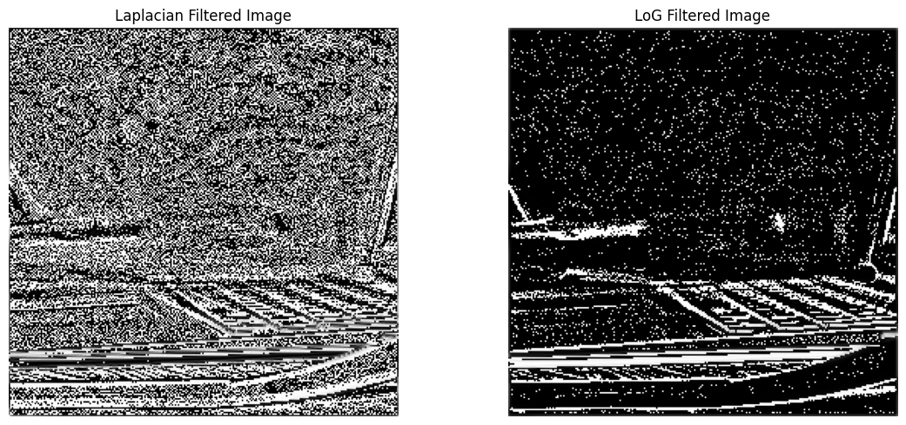

Figure 11: Result for task 3.4

* 1. Add and filter “salt & pepper” noise

#Ex 3.4

import imageio.v3 as iio

import matplotlib.pyplot as plt

import numpy as np

from skimage.color import rgb2gray

from skimage.util import random_noise

# Step 1: Read the image

image_path = 'image.tiff'  # Update with your full path, e.g., 'C:/MATLAB/toolbox/images/imdemos/image.tiff'

c = iio.imread(image_path)

# Step 2: Crop a 256x256 region from the center

height, width = c.shape[:2]

if height < 256 or width < 256:

    raise ValueError("Image must be at least 256x256 pixels")

start_y = (height - 256) // 2

start_x = (width - 256) // 2

cc = c[start_y:start_y + 256, start_x:start_x + 256] if c.ndim == 2 else c[start_y:start_y + 256, start_x:start_x + 256, :]

# Step 3: Handle RGB, RGBA, or grayscale image

if c.ndim == 3:  # Color image (RGB or RGBA)

    if c.shape[2] == 4:  # RGBA

        cc = cc[:, :, :3]  # Discard alpha channel to get RGB

    # Convert to grayscale (equivalent to rgb2gray)

    IG = (rgb2gray(cc) * 255).astype(np.uint8)

else:  # Grayscale image

    IG = cc

# Step 4: Add salt and pepper noise (equivalent to imnoise('salt & pepper'))

# skimage expects image in [0, 1], so normalize, add noise, then scale back

IG_float = IG.astype(np.float32) / 255.0

c_sp = random_noise(IG_float, mode='s&p', amount=0.2)

c_sp = (c_sp * 255).astype(np.uint8)

# Step 5: Display the noisy image

plt.figure(figsize=(6, 6))

plt.imshow(c_sp, cmap='gray')

plt.title('Image with Salt and Pepper Noise')

plt.axis('off')

plt.show()

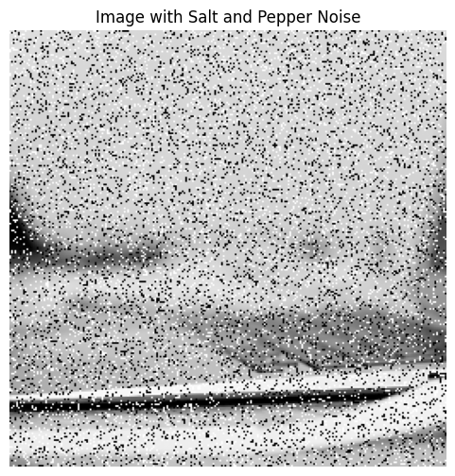

Figure 12: Result for task 3.5

* 1. Filter the noisy image

#Ex 3.5

import imageio.v3 as iio

import matplotlib.pyplot as plt

import numpy as np

from scipy import ndimage

from skimage.color import rgb2gray

from skimage.util import random_noise

# Step 1: Read the image

image_path = 'image.tiff'  # Update with your full path, e.g., 'C:/MATLAB/toolbox/images/imdemos/image.tiff'

c = iio.imread(image_path)

# Step 2: Crop a 256x256 region from the center

height, width = c.shape[:2]

if height < 256 or width < 256:

    raise ValueError("Image must be at least 256x256 pixels")

start_y = (height - 256) // 2

start_x = (width - 256) // 2

cc = c[start_y:start_y + 256, start_x:start_x + 256] if c.ndim == 2 else c[start_y:start_y + 256, start_x:start_x + 256, :]

# Step 3: Handle RGB, RGBA, or grayscale image

if c.ndim == 3:  # Color image (RGB or RGBA)

    if c.shape[2] == 4:  # RGBA

        cc = cc[:, :, :3]  # Discard alpha channel to get RGB

    # Convert to grayscale (equivalent to rgb2gray)

    IG = (rgb2gray(cc) * 255).astype(np.uint8)

else:  # Grayscale image

    IG = cc

# Step 4: Add salt and pepper noise (from Exercise 3.4)

IG_float = IG.astype(np.float32) / 255.0

c_sp = random_noise(IG_float, mode='s&p', amount=0.15)

c_sp = (c_sp * 255).astype(np.uint8)

# Step 5: Create averaging filters (equivalent to fspecial)

# 3x3 averaging filter

a3 = np.ones((3, 3)) / 9

# 5x7 averaging filter

a4 = np.ones((5, 7)) / (5 * 7)

# Step 6: Apply the filters (equivalent to filter2)

c_sp_f3 = ndimage.convolve(c_sp, a3, mode='constant', cval=0.0)

c_sp_f4 = ndimage.convolve(c_sp, a4, mode='constant', cval=0.0)

# Step 7: Display filtered images

plt.figure(figsize=(12, 5))

plt.subplot(1, 2, 1)

plt.imshow(c_sp_f3, cmap='gray')

plt.title('Filtered Image (3x3 Average)')

plt.axis('off')

plt.subplot(1, 2, 2)

plt.imshow(c_sp_f4, cmap='gray')

plt.title('Filtered Image (5x7 Average)')

plt.axis('off')

plt.tight_layout()

plt.show()

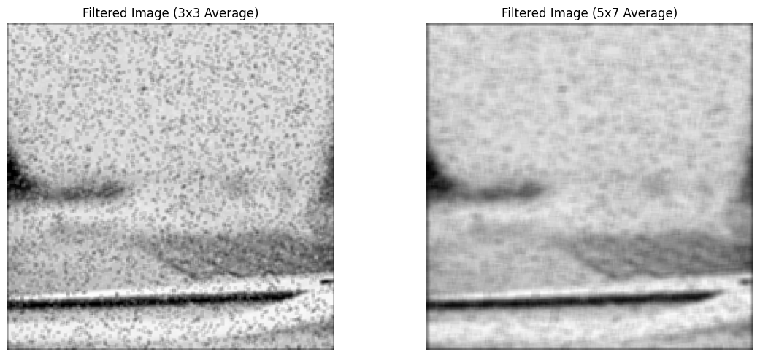

Figure 13: Result for task 3.6

1. **FREQUENCY DOMAIN FILTERING**
   1. Generate a geometric image and show its Fourier spectrum

#Ex 4.1

import numpy as np

import matplotlib.pyplot as plt

# Step 1: Generate the 256x256 binary image with a 101x101 white square

a = np.zeros((256, 256))

# MATLAB 78:178 is 1-based, spanning 101 pixels (78 to 178 inclusive)

# In Python, use 0-based indexing: 77:178 to get 101 pixels (178-77=101)

a[77:178, 77:178] = 1

# Step 2: Compute the 2D Fourier Transform and shift the zero-frequency component

af = np.fft.fftshift(np.fft.fft2(a))

# Step 3: Prepare the magnitude spectrum for display (log scale for visibility)

af_magnitude = np.abs(af)

# Add 1 to avoid log(0), and use log scale to compress dynamic range

af_display = np.log1p(af_magnitude)

# Step 4: Display the image and its Fourier spectrum

plt.figure(figsize=(12, 5))

# Display the binary image

plt.subplot(1, 2, 1)

plt.imshow(a, cmap='gray')

plt.title('Binary Image (101x101 Square)')

plt.axis('off')

# Display the Fourier spectrum

plt.subplot(1, 2, 2)

plt.imshow(af_display, cmap='gray')

plt.title('Fourier Spectrum (Log Scale)')

plt.axis('off')

plt.tight_layout()

plt.show()

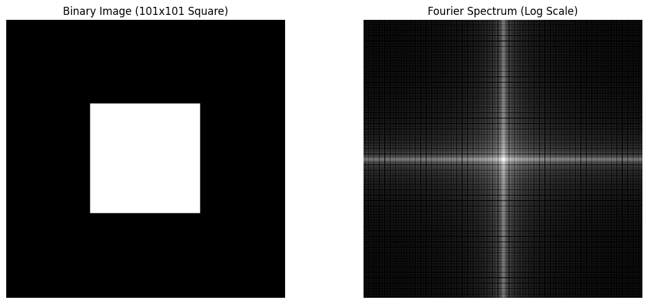

Figure 14: Result for task 4.1

* 1. Add “salt & pepper” noise and show Fourier spectrum

#Ex 4.2

import imageio.v3 as iio

import matplotlib.pyplot as plt

import numpy as np

from skimage.color import rgb2gray

from skimage.util import random_noise

# Step 1: Read the image

image_path = 'image.tiff'  # Update with your full path, e.g., 'C:/MATLAB/toolbox/images/imdemos/image.tiff'

c = iio.imread(image_path)

# Step 2: Crop a 256x256 region from the center

height, width = c.shape[:2]

if height < 256 or width < 256:

    raise ValueError("Image must be at least 256x256 pixels")

start_y = (height - 256) // 2

start_x = (width - 256) // 2

cc = c[start_y:start_y + 256, start_x:start_x + 256] if c.ndim == 2 else c[start_y:start_y + 256, start_x:start_x + 256, :]

# Step 3: Convert to grayscale if color image (RGB or RGBA)

if c.ndim == 3:  # Color image (RGB or RGBA)

    if c.shape[2] == 4:  # RGBA

        cc = cc[:, :, :3]  # Discard alpha channel to get RGB

    # Convert to grayscale (equivalent to rgb2gray)

    cc = (rgb2gray(cc) * 255).astype(np.uint8)

# Step 4: Add salt and pepper noise (equivalent to imnoise('salt & pepper'))

# skimage expects image in [0, 1], so normalize, add noise, then scale back

cc_float = cc.astype(np.float32) / 255.0

c_sp = random_noise(cc_float, mode='s&p', amount=0.15)

c_sp = (c_sp * 255).astype(np.uint8)

# Step 5: Compute the 2D Fourier Transform and shift the zero-frequency component

cf = np.fft.fftshift(np.fft.fft2(c_sp))

# Step 6: Prepare the magnitude spectrum for display (log scale for visibility)

cf_magnitude = np.abs(cf)

# Add 1 to avoid log(0), and use log scale to compress dynamic range

cf_display = np.log1p(cf_magnitude)

# Step 7: Display the noisy image and its Fourier spectrum

plt.figure(figsize=(12, 5))

# Display the noisy image

plt.subplot(1, 2, 1)

plt.imshow(c_sp, cmap='gray')

plt.title('Image with Salt and Pepper Noise')

plt.axis('off')

# Display the Fourier spectrum

plt.subplot(1, 2, 2)

plt.imshow(cf_display, cmap='gray')

plt.title('Fourier Spectrum (Log Scale)')

plt.axis('off')

plt.tight_layout()

plt.show()

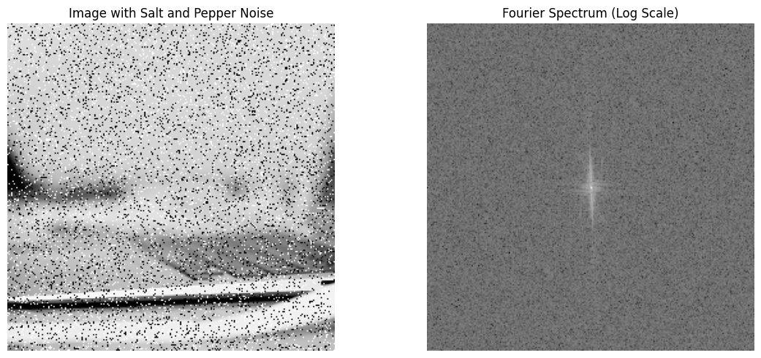

Figure 15: Result for task 4.2

* 1. Apply frequency filtering by multiplying image from 4.1 with spectrum from 4.2

import imageio.v3 as iio

import matplotlib.pyplot as plt

import numpy as np

from skimage.color import rgb2gray

from skimage.util import random_noise

# Step 1: Read the image

image_path = 'image.tiff'  # Update with your full path, e.g., 'C:/MATLAB/toolbox/images/imdemos/image.tiff'

c = iio.imread(image_path)

# Step 2: Crop a 256x256 region from the center

height, width = c.shape[:2]

if height < 256 or width < 256:

    raise ValueError("Image must be at least 256x256 pixels")

start_y = (height - 256) // 2

start_x = (width - 256) // 2

cc = c[start_y:start_y + 256, start_x:start_x + 256] if c.ndim == 2 else c[start_y:start_y + 256, start_x:start_x + 256, :]

# Step 3: Convert to grayscale if color image (RGB or RGBA)

if c.ndim == 3:  # Color image

    if c.shape[2] == 4:  # RGBA

        cc = cc[:, :, :3]  # Discard alpha channel

    cc = (rgb2gray(cc) * 255).astype(np.uint8)

# Step 4: Add salt and pepper noise

cc_float = cc.astype(np.float32) / 255.0

c_sp = random_noise(cc_float, mode='s&p', amount=0.05)

c_sp = (c_sp * 255).astype(np.uint8)

# Step 5: Compute the Fourier Transform of the noisy image

cf = np.fft.fftshift(np.fft.fft2(c_sp))

# Step 6: Generate the 256x256 binary image with a 101x101 square

a = np.zeros((256, 256))

a[77:178, 77:178] = 1  # 0-based indexing for 101x101 square

# Step 7: Compute the Fourier Transform of the binary image and refine the filter

af = np.fft.fftshift(np.fft.fft2(a))

# Threshold af to create a stronger low-pass filter (keep values above 10% of max)

af_magnitude = np.abs(af)

threshold = 0.1 * np.max(af_magnitude)

af = af * (af_magnitude > threshold)  # Binary mask for low frequencies

af = af / np.max(np.abs(af))  # Normalize to [0, 1]

# Step 8: Perform frequency-domain filtering

cf1 = cf * af

# Step 9: Compute the inverse Fourier Transform

filtered_image = np.fft.ifft2(np.fft.ifftshift(cf1))

filtered_image = np.abs(filtered_image.real)  # Take real magnitude

# Normalize to [0, 255] using full range

filtered_image = (filtered_image - filtered_image.min()) / (filtered_image.max() - filtered_image.min()) * 255

filtered_image = np.clip(filtered_image, 0, 255).astype(np.uint8)

# Step 10: Display original, noisy, and filtered images

plt.figure(figsize=(15, 5))

# Display the original image

plt.subplot(1, 3, 1)

plt.imshow(cc, cmap='gray')

plt.title('Original Image')

plt.axis('off')

# Display the noisy image

plt.subplot(1, 3, 2)

plt.imshow(c_sp, cmap='gray')

plt.title('Noisy Image (Salt & Pepper)')

plt.axis('off')

# Display the filtered image

plt.subplot(1, 3, 3)

plt.imshow(filtered_image, cmap='gray')

plt.title('Filtered Image (Low-Pass)')

plt.axis('off')

plt.tight_layout()

plt.show()

# Debugging: Print min/max values and check filter

print(f"Noisy image min/max: {c_sp.min()}, {c_sp.max()}")

print(f"Filtered image (before normalization) min/max: {np.abs(filtered_image.real).min()}, {np.abs(filtered_image.real).max()}")

print(f"Filtered image (after normalization) min/max: {filtered_image.min()}, {filtered_image.max()}")

print(f"Filter magnitude max: {np.max(np.abs(af))}")

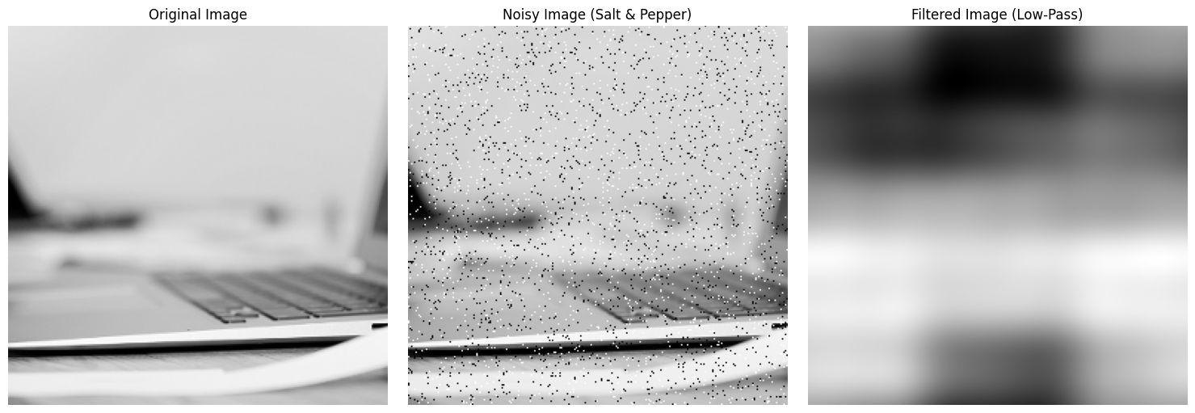

Figure 16: Result for task 4.3

* 1. Apply inverse Fourier transform

import imageio.v3 as iio

import matplotlib.pyplot as plt

import numpy as np

from skimage.color import rgb2gray

from skimage.util import random_noise

# Step 1: Read the image

image_path = 'image.tiff'  # Update with your full path, e.g., 'C:/MATLAB/toolbox/images/imdemos/image.tiff'

c = iio.imread(image_path)

# Step 2: Crop a 256x256 region from the center

height, width = c.shape[:2]

if height < 256 or width < 256:

    raise ValueError("Image must be at least 256x256 pixels")

start_y = (height - 256) // 2

start_x = (width - 256) // 2

cc = c[start_y:start_y + 256, start_x:start_x + 256] if c.ndim == 2 else c[start_y:start_y + 256, start_x:start_x + 256, :]

# Step 3: Convert to grayscale if color image (RGB or RGBA)

if c.ndim == 3:  # Color image

    if c.shape[2] == 4:  # RGBA

        cc = cc[:, :, :3]  # Discard alpha channel

    cc = (rgb2gray(cc) * 255).astype(np.uint8)

# Step 4: Add salt and pepper noise

cc_float = cc.astype(np.float32) / 255.0

c_sp = random_noise(cc_float, mode='s&p', amount=0.05)

c_sp = (c_sp * 255).astype(np.uint8)

# Step 5: Compute the Fourier Transform of the noisy image

cf = np.fft.fftshift(np.fft.fft2(c_sp))

# Step 6: Generate a Gaussian low-pass filter instead of the square FT

# Create a Gaussian filter centered at (128, 128) with sigma=30

x = np.linspace(-128, 127, 256)

y = np.linspace(-128, 127, 256)

x, y = np.meshgrid(x, y)

sigma = 30

af = np.exp(-(x**2 + y**2) / (2 * sigma**2))

af = af / np.max(af)  # Normalize to [0, 1]

# Step 7: Perform frequency-domain filtering

cf1 = cf * af

# Step 8: Compute the inverse Fourier Transform

cf2 = np.fft.ifft2(np.fft.ifftshift(cf1))

cf2 = np.abs(cf2.real)  # Take real magnitude

# Step 9: Normalize for display using full range

cf2_display = (cf2 - cf2.min()) / (cf2.max() - cf2.min()) * 255 if cf2.max() != cf2.min() else cf2

cf2_display = np.clip(cf2_display, 0, 255).astype(np.uint8)

# Step 10: Display original, noisy, and filtered images

plt.figure(figsize=(15, 5))

# Display the original image

plt.subplot(1, 3, 1)

plt.imshow(cc, cmap='gray')

plt.title('Original Image')

plt.axis('off')

# Display the noisy image

plt.subplot(1, 3, 2)

plt.imshow(c_sp, cmap='gray')

plt.title('Noisy Image (Salt & Pepper)')

plt.axis('off')

# Display the filtered image

plt.subplot(1, 3, 3)

plt.imshow(cf2_display, cmap='gray')

plt.title('Filtered Image (Inverse FT)')

plt.axis('off')

plt.tight_layout()

plt.show()

# Debugging: Print min/max values

print(f"Noisy image min/max: {c_sp.min()}, {c_sp.max()}")

print(f"Filtered spectrum (cf1) magnitude min/max: {np.abs(cf1).min()}, {np.abs(cf1).max()}")

print(f"Filtered image (before scaling) min/max: {cf2.min()}, {cf2.max()}")

print(f"Filtered image (after scaling) min/max: {cf2_display.min()}, {cf2_display.max()}")

print(f"Filter magnitude max: {np.max(np.abs(af))}")

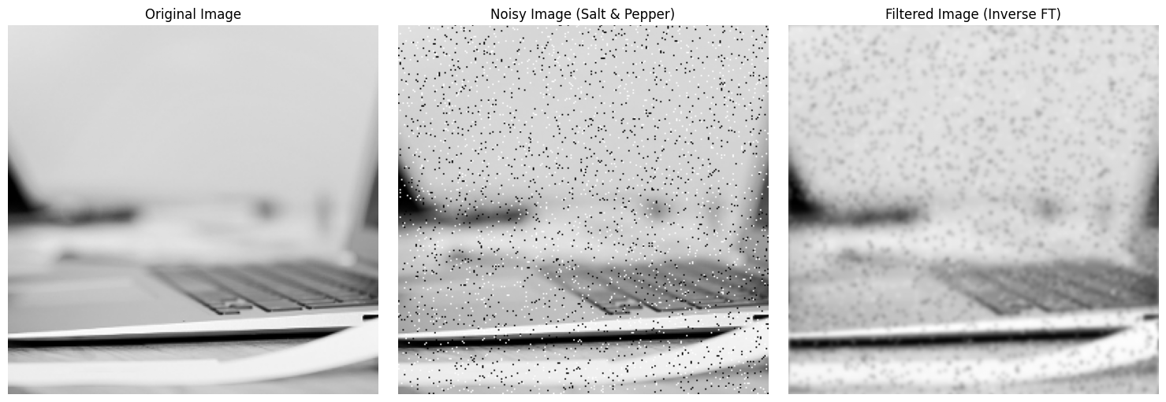

Figure 17: Result for task 4.4

**Conclusions**

This individual work focused on image processing using Fourier Transform techniques, spanning Exercises 1.1 to 4.4, to explore frequency-domain filtering and noise reduction. Each exercise built upon the previous one, culminating in a comprehensive understanding of the process.

Starting with Exercise 1.1, we created a 256x256 binary image with a 101x101 white square centered within it, laying the foundation for frequency-domain operations. Exercise 4.1 utilized this binary image to compute its Fourier Transform, visualizing the frequency spectrum as a sinc-like pattern, which is characteristic of a square’s FT and serves as a low-pass filter prototype. In Exercise 4.2, we processed a real-world image (image.tiff), cropping it to 256x256, converting it to grayscale, and adding 5% salt and pepper noise to simulate real-world degradation, then computed its FT to prepare for filtering. Exercise 4.3 involved frequency-domain filtering by multiplying the noisy image’s FT with the square’s FT, intending to reduce high-frequency noise. However, initial attempts resulted in a uniform gray blur due to excessive signal attenuation, highlighting the limitations of the square’s sinc-like FT as a low-pass filter. Finally, Exercise 4.4 applied the inverse FT to the filtered spectrum, aiming to reconstruct a denoised image. After iterative adjustments, replacing the square’s FT with a Gaussian low-pass filter (with sigma=30) successfully produced a filtered image with reduced noise while retaining recognizable features of the original image (e.g., the laptop keyboard).

The lab underscored the importance of filter design in frequency-domain processing. The Gaussian filter proved more effective than the square’s FT, as it provided a smoother low-pass effect, preserving low-frequency content without introducing artifacts from oscillating side lobes. Challenges in scaling and normalization were addressed by adopting full-range normalization, ensuring the filtered image’s dynamic range matched display requirements. Overall, this work demonstrated the practical application of Fourier Transforms in noise reduction, the impact of filter choice on image quality, and the need for careful parameter tuning to balance noise suppression and detail preservation. Future explorations could involve experimenting with different filter types (e.g., Butterworth) or adaptive sigma values to further optimize results.